BLUDIVE BD40 PRO Torch Review

Lynn Miner November 2024

This is a nonpaid independent review of the Bludive BD40 Pro dive torch.

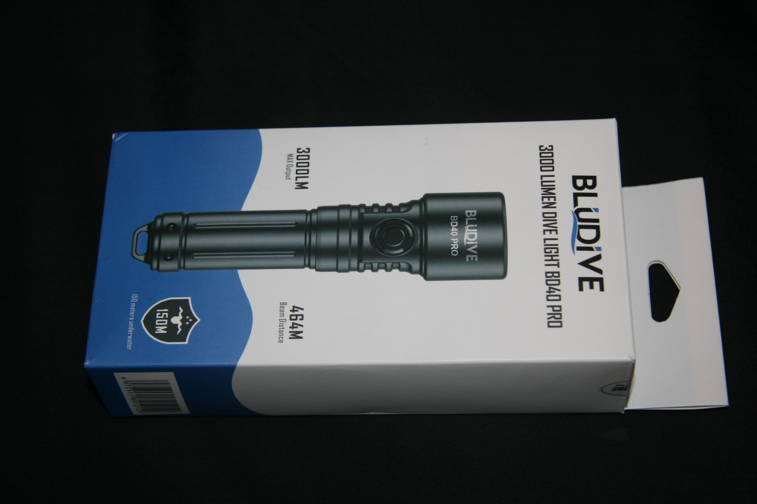The torch kit comes in a cardboard box. I make mention of this because some torch manufacturers sell their torches in a plastic carrying case. I like that Bludive has elected to supply a simple box because the cases from other sources just wind up in the trash because they take up too much room in luggage thereby adding to the massive plastics trash problem. A small point perhaps but a big one to me to know they have some level of environmental awareness.

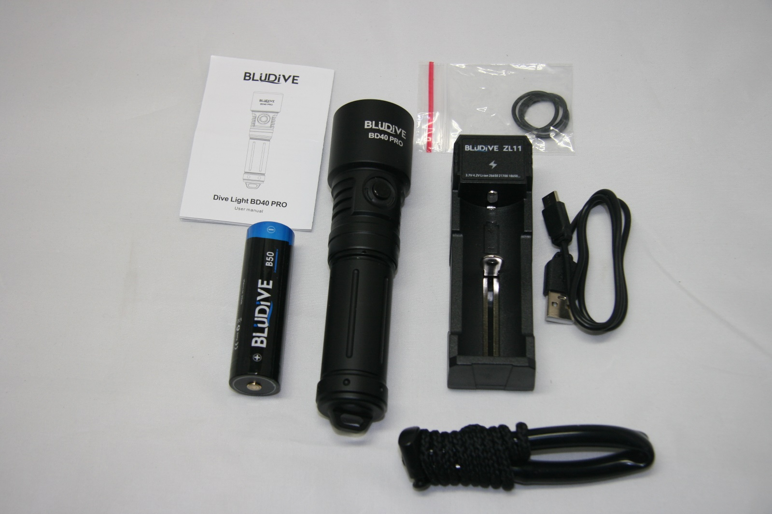

The kit consists of the torch, 21700 battery, charger w/USB C cable, lanyard, spare O-Ring set and instructions.

The fit and finish if the torch is exceptional in every respect. Beautifully anodized, gold-plated internal contacts, double O-Ring configuration. The machining is very precise and ergonomic. The torch features a magnetic push button ON/OFF switch with an LED surround to indicate battery condition.

I make specific mention of the gold-plated battery contacts. This is rare to see in this price point because it shows a very high degree of design consideration. Most manufacturers use chrome plated springs which have a tendency to corrode over time. The BD40 Pro contact springs are gold on both ends of the battery.

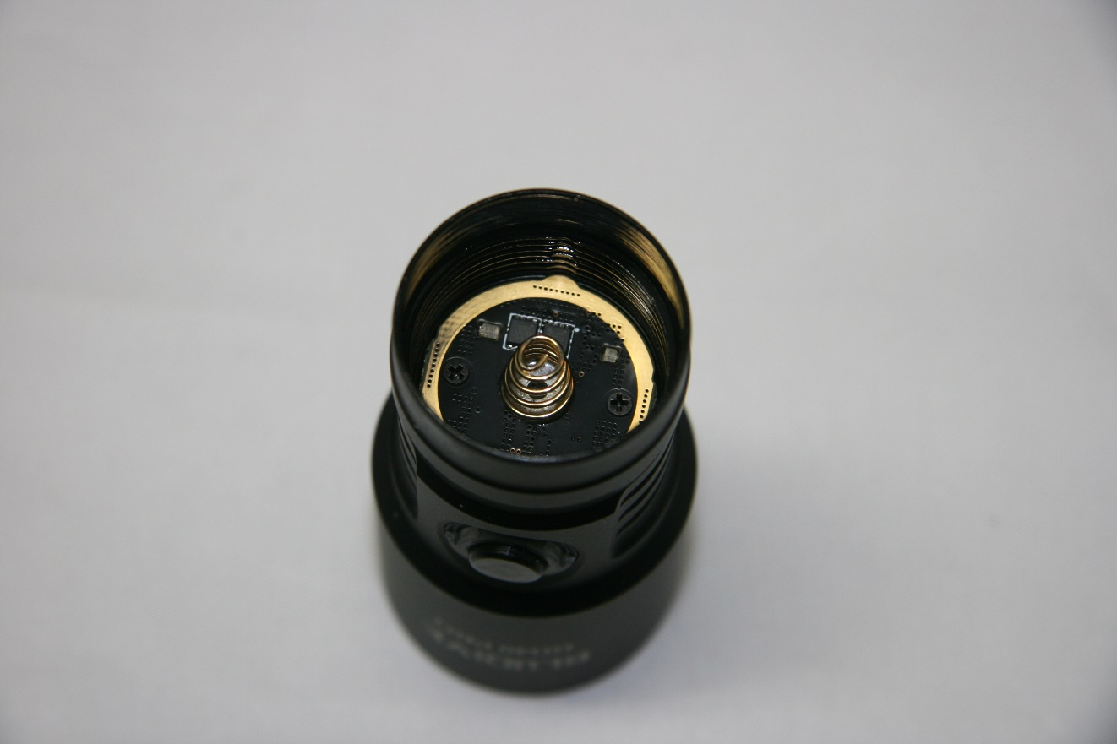

This speaks well for the long service life of the torch.

The torch is rated to a depth of 150m. This is well beyond both the recreational dive depth as well as the technical dive depth. However, I have tested hundreds of torches over the years and I have found that many don’t even come close to the rated depth rating. Of course, who has the equipment to verify that specification? ***I do!*** I use a commercial grade pressure test vessel. I usually only test to 100m because this is the maximum tech diver depth but as noted above, I’ve tested many torches rated to 100m and beyond only to have them fail at 50m. However, if they claim a greater depth, I test to that depth.

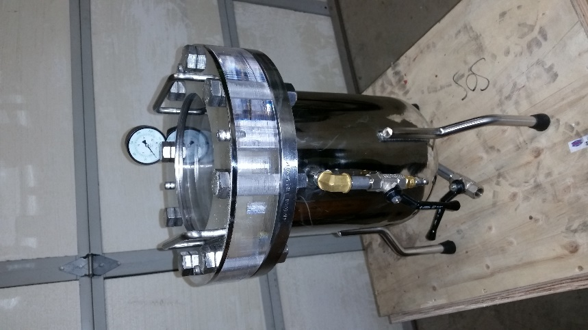

FireDiveGear.Com Pressure Test Vessel

Consequently, when I do a review, this is the first spec that I verify. This torch met their rated depth specification.

The torch is shipped with a 21700 battery. I believe that is what gives the torch the “Pro” designation. The 21700 is an upgrade to the older 18650 style batteries in that they have more capacity which equates to longer burn time. I confess that I have no previous history on the service life of the Bludive batteries so I can make no comment as to overall life and number of charge cycles. The battery is rated at 5000 mA/hr which is kind of an industry standard. The charger is also on the higher end of the quality scale compared with some suppliers.

So far, I’ve only had a handful of dives with this torch but the performance is exceptional. The burn times exceeded those in the spec sheet.

One feature that I personally find to be required in a torch is a magnetic ON/OFF switch. The alternative is a twist action switch. These are fine if the end user knows how to operate a “twist-to-flood” torch, but in a rental situation, a twist switch is a horrible option. Additionally, from a retail perspective, they are bad because you are taking in flooded torches on warranty because the customer says it was defective when he unscrewed the head underwater, not realizing that it only takes about ¼ turn to activate/deactivate the torch. Of course, there is no obligation to accept a dead torch in this situation but if you want to keep your customers happy, you have to “eat it”.

The more relevant specifications are as follows:

***RATED*** Output - Turbo 3000lm with high at 2000lm and medium at 800lm and low at 400lm in four steps. There is no easy way to accurately test the output luminosity without an integrating sphere. This is a very expensive apparatus that far exceeds my budget. I can say that the torch meets or exceeds other torches with similar brightness specs using my spectroradiometer on a precision optical rail.

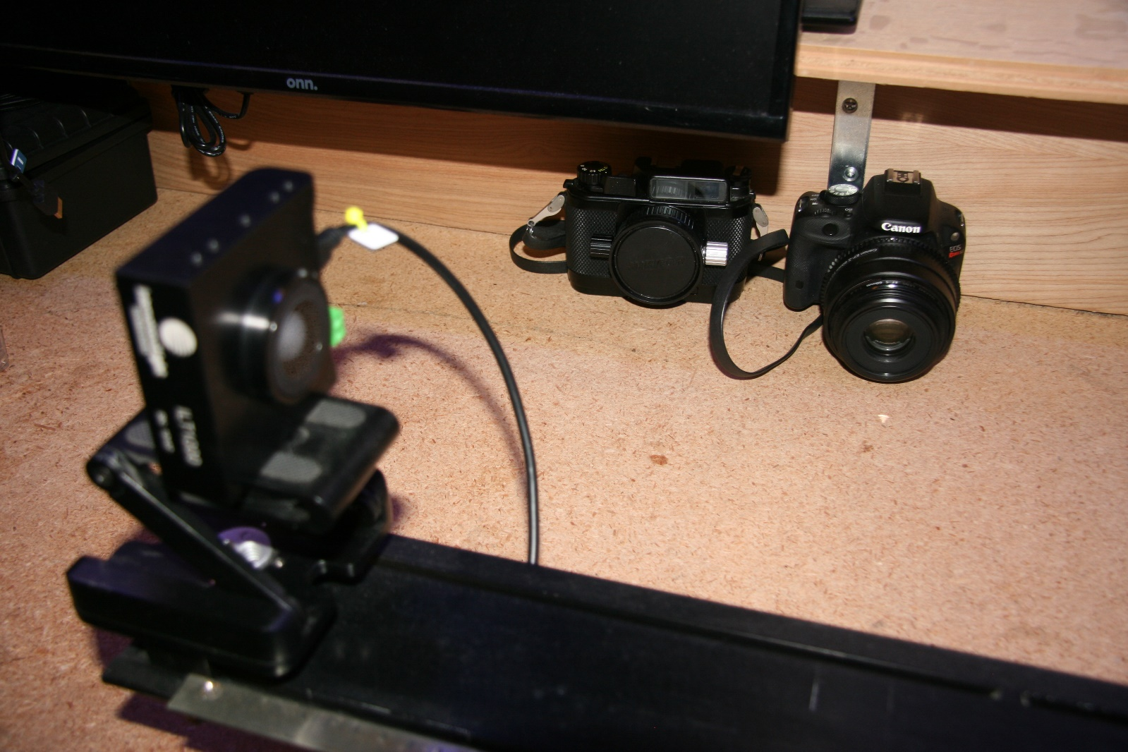

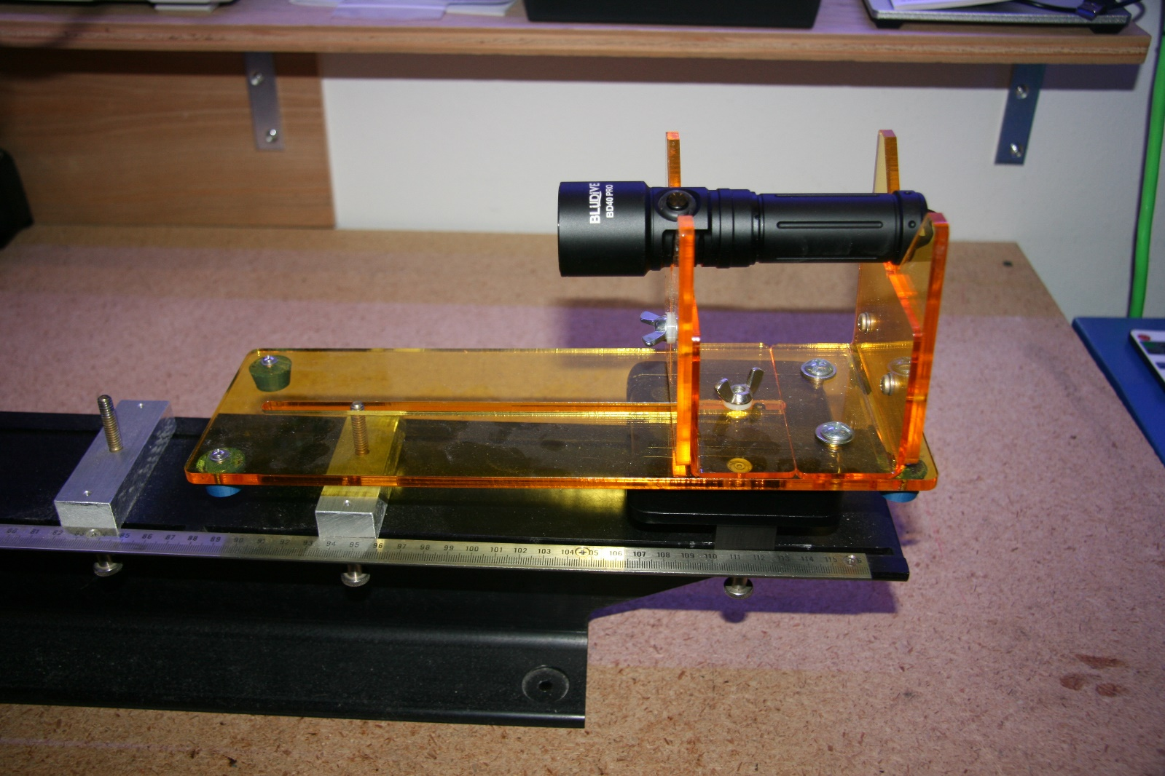

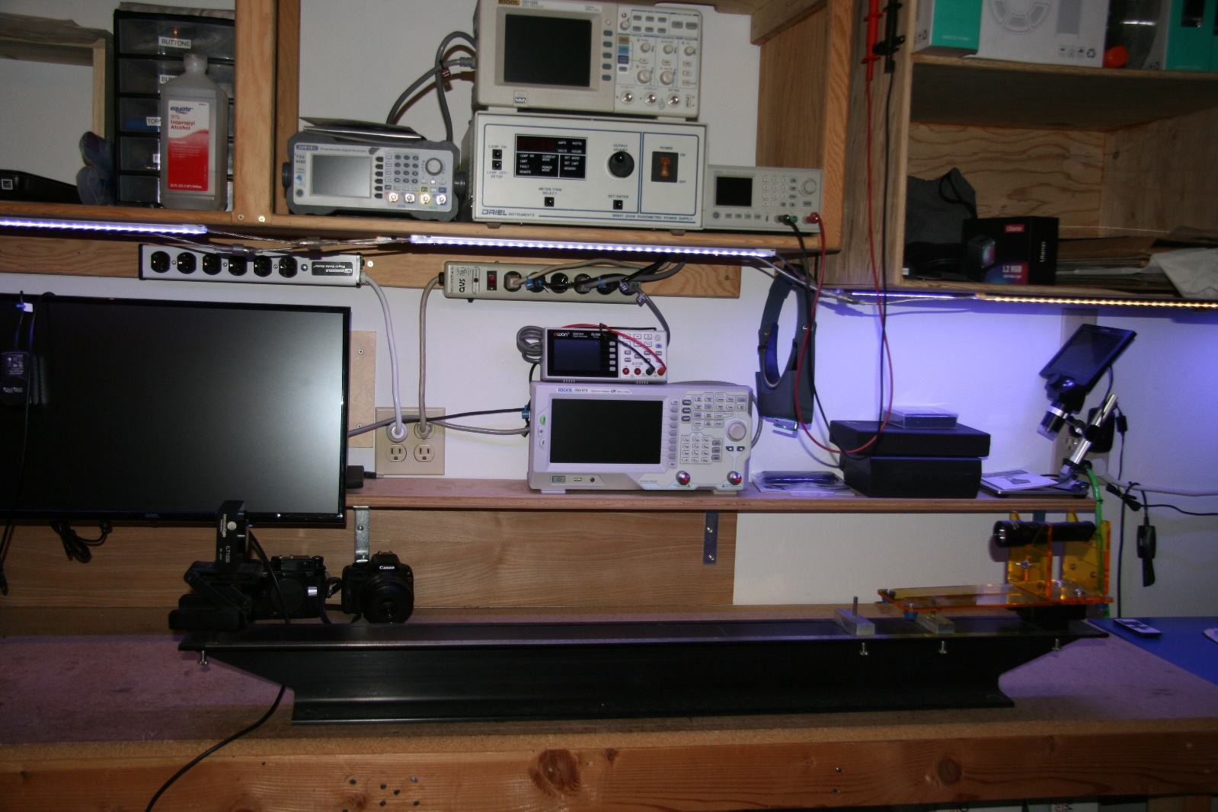

Runtime - 2hr, 2hr, 3.3hr, 4.4hr respectively

Dimensions – 149.5mm Length, 27mm dia body, 37mm dia head

Weight - 215g ***with*** battery. I don’t understand why manufacturers always spec the weight without a battery. Who uses it like that? So, I weigh it!

Beam angle - 4.6 degrees

Beam Distance – There is a standard formula for calculating beam distance: Divide the candela rating by 0.25 and take the square root of that number. This torch has a rated beam distance of 464m. This seems dubious to me. Yes, that spec matches the formula but I can see the reflection off a rock outdoors on a mountain side from 2km away and in poor diving conditions with lots of turbidity, the distance can only be a few cm. I don’t really know how to interpret that specification in the real world.

Conclusion:

This Bludive torch is extremely well made and reliable. It is an excellent value. Price is of course dependent on where you purchase it. With online sales as low as $109 and retail dive shop sales at about $150. That price point puts it far ahead of other lesser performing units in that range. This is one of the finest handheld torches I have ever tested. I don’t know how long Bludive has been in the market as they are new to me but based on this evaluation, there are none finer and I look forward to seeing some of their other products in the future. I would give this torch kit a 5-star rating. All Pros and no Cons.